Instituto Superior Técnico

Mestrado Integrado em Engenharia Electrotécnica e de Computadores

SIBD
2nd Project Assignment

Group number: 12

Number: 84106 Name: John Daniel Fidalgo Mendonça
Number: 84180 Name: Rúben dos Santos Gomes
Number: 91410 Name: Renato Fraga Trevizan

Queries

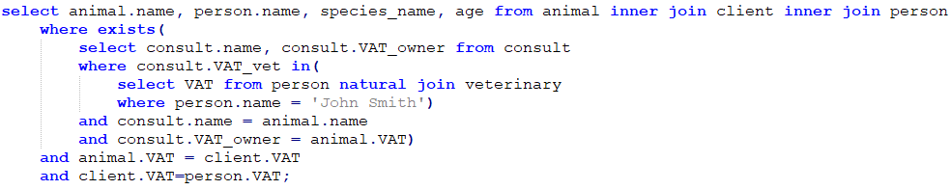
- List the name, owner name, species, and age, for all animals that participated in consults with a veterinary doctor named John Smith.

In this query, we select the animals whose primary key exists in consults where the veterinary is John Smith. The query result is presented in figure 1.
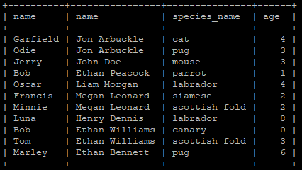

Figure 1 - Query 1 result

- List the name of all indicators measured in milligrams and with a reference value above 100. The names should be presented together with the corresponding reference value, and sorted according to the reference value, in descending order
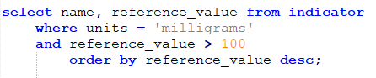

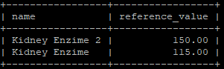
Figure 2 - Query 2 result

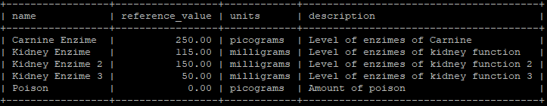
By analysing figure 3, we see the query 2 result lists only the indicators that meet the requirements.
Figure 3- List of all indicators

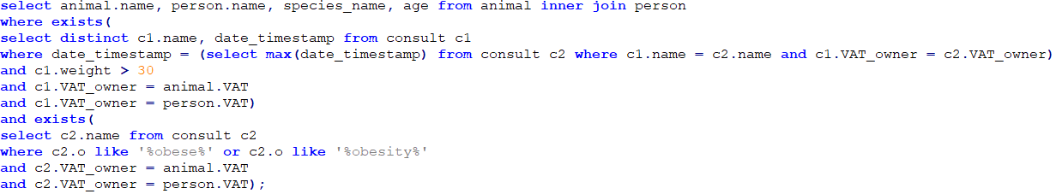
- List the name, owner name, species and age for all animals with the most recent weight above 30 kilograms, and where the objective part of any SOAP note, associated to consults of that animal, mentions terms like obesity or obese.

In this query, we select the animals that exists in the most recent consult with their owners, meeting weight > 0 in that consult and that exists in any consult where the objective part of any SOAP note mentions terms like obesity or obese
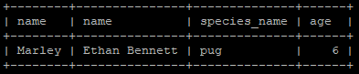

Figure 4 - Query 3 result

In the next figure, we show the query result of listing all consults recorded in the database. The 1st marked row represents the most recent consult of Luna, where weight is above 30 kg but the objective part does not mention terms like obesity or obese. The 2nd marked row represents a consult of Oscar, where weight is above 30 kg and the objective part mentions terms like obesity or obese, but it is not the most recent consult of Oscar. The 3rd marked row represents the most recent consult of Marley where weight is above 30 kg and the objective part mentions obesity so this was the only row that was chosen.
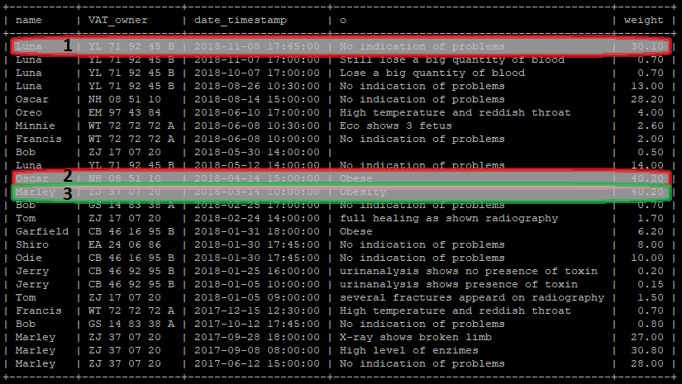
Figure 5 - List of all consults recorded in the database

- List the name, VAT and address of all clients of the hospital that are not owners of animals.

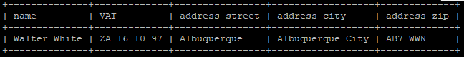
Walter White is the only person that is recorded in client relation, but that any animal as his VAT in animal.VAT.
Figure 6- Query 4 result
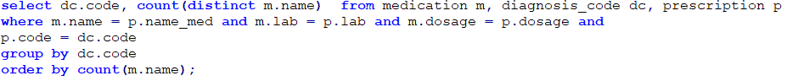
- For each possible diagnosis, list the number of distinct medication names that have been prescribed to treat that condition. Sort the results according to the number of distinct medication names, in ascending order.
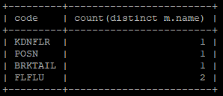
Figure 7- Query 5 result

By listing all the prescriptions, selecting the code of the diagnosis and the corresponding medication name we confirm the results. The list of all prescriptions is presented in figure 8.
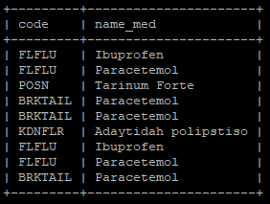
Figure 8- List of all prescriptions

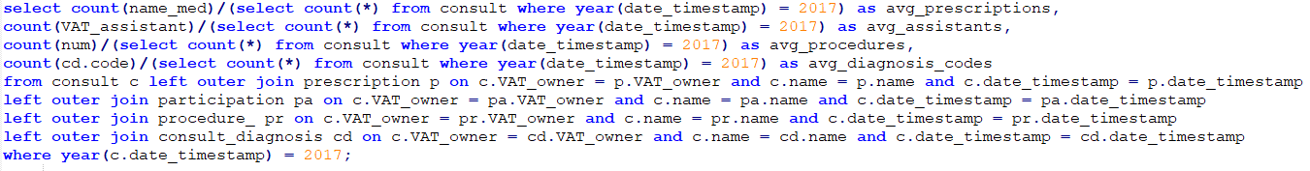
- Present the average number of assistants, procedures, diagnostic codes, and prescriptions involved in consults from the year of 2017.
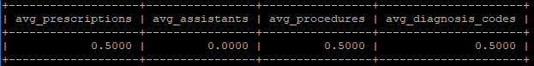
In this query we count the total number of all assistants, procedures, diagnostic codes, and prescriptions involved in consults from the year of 2017 and we divide it by the total number of consults from the year of 2017.
Figure 9- Query 6 result
From 2017 there were 3 prescriptions, 0 assistants, 3 procedures and 3 diagnosis in a list of 6 consults.

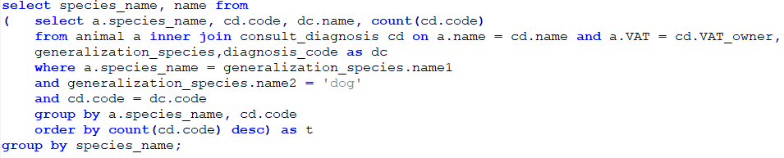
- For each animal sub-species of dog, present the name of the most common disease (i.e., the name associated to the most frequent diagnostic code for consults involving animals of that species).

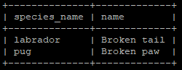
Figure 10 - Query 7 result

With this implementation, if there are 2 diagnostic names that are equally frequent for a sub-specie of dog, only one of them will be shown.

- List the names of individuals that are simultaneously clients of the hospital (i.e., owners of animals or clients that have brought animals to consults) and employees of the hospital (i.e., veterinary doctors or assistants).
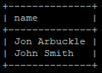
Figure 11 - Query 8 result

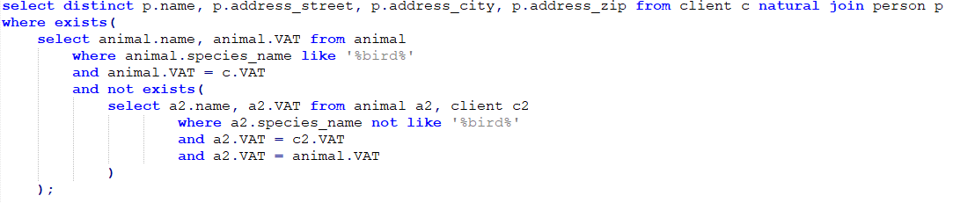
- List the names and addresses of clients that only own birds as their pets (i.e., the clients for whom all the owned animals contain the word bird as part of the species name).
In this query we select all the persons that have an animal containing the word bird as part of the species name and that have not any animal not containing the word bird as part of the species name.
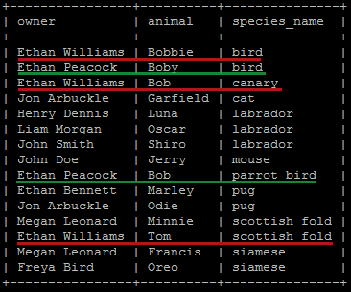
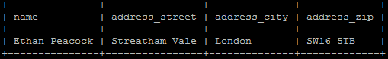
Figura 12 - Query 9 result

Figura 13 - List of animals and corresponding owners

In the figure above, that represents the list of all animals and corresponding owners, we mark the 2 clients that have birds. We can see that Ethan Williams has two animals that have not the word bird in the species_name. Ethan Peacock have 2 pets and both have the word bird in the species_name as we can see in query 9 result.

Indexes
1.
create index person_client
on client(VAT);

create index animal_client
on animal(VAT);

create index vet_person
on veterinary(VAT);

To improve the performance of Query 1, we can use indexes that store records regarding VAT numbers of all tables involved. With these indexes we can quickly collect the VAT number of the veterinary ‘John Smith’ and associate the animal’s owner VAT with his name on person. These indexes therefore reduce the overall time required to perform joins between tables.
2.
create index ind_units
on indicator(units);
create index ind_ref
on indicator(reference_value);

As requested in the query, we wish to locate indicators that have milligrams as their units and a reference value of over 100. Instead of traversing the whole table, we can instead index the required fields units and reference_value. Although not implemented in mysql, a conditional index on reference_value > 100 would yield the best performance if we performed an intersection between this index and ind_units. This however would make this index only usable in similar situation, therefore the general ind_ref performs similarly and provides better performance on insertion and deletion.

Database modifications

- update person
set person.address_street = 'Main St',
person.address_city = 'Croydon'
where person.name = 'John Smith' and person.VAT in (select client.VAT from client);

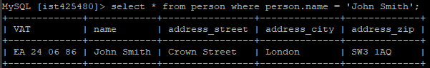
Figure 14 - Information about John Smith before modification 1
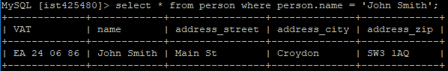
Figure 15 - Information about John Smith after modification 1
- update indicator
set indicator.reference_value = indicator.reference_value * 1.1
where indicator.units = 'milligrams' and indicator.name in
(select produced_indicator.indicator_name
from produced_indicator natural join test_procedure
where test_procedure.type = 'blood');
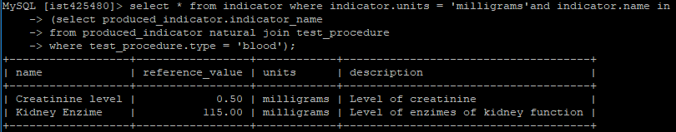
Figure 16 - Indicator's reference_value before modification 2
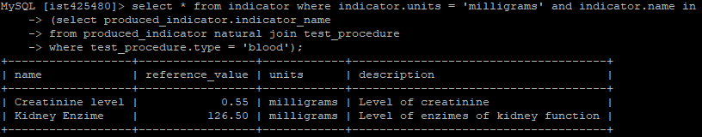
Figure 17 - Indicator's reference_value after modification 2

- delete from client
where client.VAT in (select person.VAT from person
where person.name = 'John Smith' and person.VAT = client.VAT);

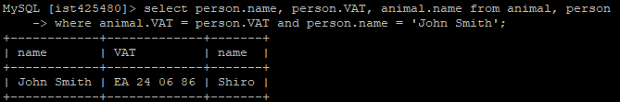
Figure 18 - John Smith's animal before modification 3
On creating the database schema, we added the constraint “on delete cascade” for all foreign keys, thus, by deleting John Smith from the Client table, all his animals are deleted, and consequently all consults where they were involved in, and so on…
Figure 19 - John Smith's modification after modification 3

- insert into diagnosis_code values('RENDES','End-Stage renal disease');
update consult_diagnosis as cd, prescription as pr
set cd.code = 'RENDES',
cd.name = cd.name,
cd.VAT_owner = cd.VAT_owner,
cd.date_timestamp = cd.date_timestamp,
pr.code = 'KDNFLR',
pr.name = pr.name,
pr.VAT_owner = pr.VAT_owner,
pr.date_timestamp = pr.date_timestamp
where exists (
select * from produced_indicator as pi
where pi.indicator_name = 'Creatinine level' and pi.value > 1.0
and pi.name = cd.name and pi.VAT_owner = cd.VAT_owner
and pi.date_timestamp = cd.date_timestamp
and pr.name = cd.name and pr.VAT_owner = cd.VAT_owner
and pr.date_timestamp = cd.date_timestamp);

The relation prescription has a foreign key from consult_diagnosis so, by updating a code on consult_diagnosis, we have also to update the corresponding code in prescription.

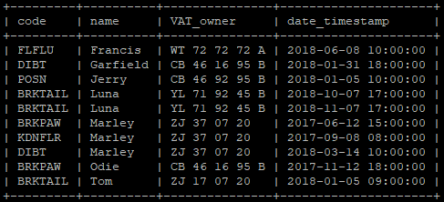
Figure 12 - List of all consult_diagnosis before update 4

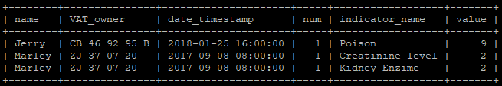
Figure 13 - List of all produced_indicators
As we can see, there is only one consult_diagnosis corresponding to kidney failure meeting all the requirements to update to end-stage renal disease. In the next figure we present the list of all consult_diagnosis after the update.

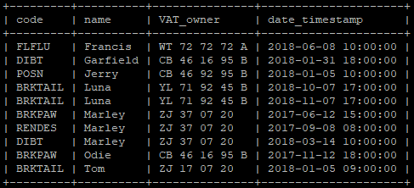
Figure 14 - List of all consult_diagnosis after update 4

As we can see, the code KDNFLR was replaced by RENDES as we would wish. Of course, the relation prescription was also changed according to consult_diagnosis.

Views
- create view dim_date as
(select distinct date_timestamp, day(date_timestamp) as day, month(date_timestamp) as month, year(date_timestamp) as year
from consult);

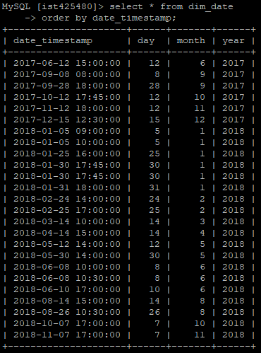
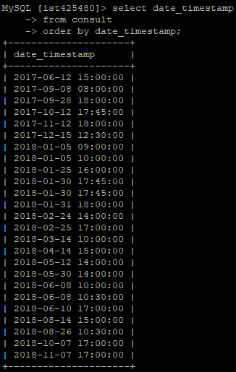
Figura 21 - List of all atributes of dim_date ordered by date
Figura 20 - List of dates of all consults ordered by date
It was necessary to use distinct because date_timestamp is not the primary key of consult, so if there were 2 consults with the same date_timestamp of differente animals, it would appear two equal date_timestamp in relation dim_date, but since date_timestamp is its key, it cannot happen.
- create view dim_animal as
(select animal.name as animal_name, animal.VAT as animal_vat,
animal.species_name as species, animal.age as age from animal)

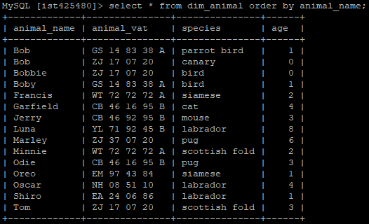
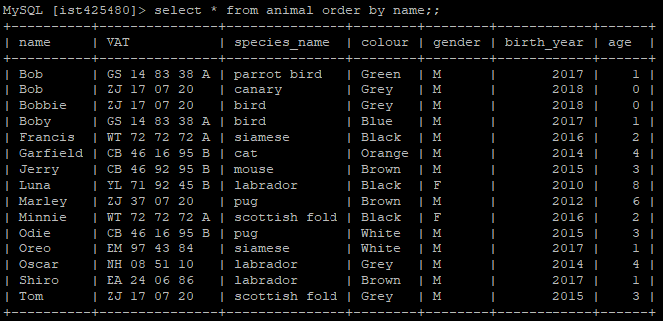
Figura 23 - List of all atributes of dim_animal ordered by name
Figura 22 - List of all animals ordered by name
Here it was not necessary to use distinct because we are selecting rows of the relation animal including its primary key so there will not be two equal rows in relation dim_animal.

create view prc_tbl as (select da.animal_name, da.animal_vat, dd.date_timestamp,count(prc.num) as procedures
from dim_date dd natural join procedure_ prc inner join dim_animal as da
where prc.name = da.animal_name and prc.VAT_owner = da.animal_vat
group by dd.date_timestamp);

create view prs_tbl as (select da.animal_name, da.animal_vat, dd.date_timestamp,count(prs.name_med) as medications
from dim_date dd natural join prescription prs inner join dim_animal as da
where prs.name = da.animal_name and prs.VAT_owner = da.animal_vat
group by dd.date_timestamp);

create view facts_consults as
select prc_tbl.animal_name as name, prc_tbl.animal_vat as vat, prc_tbl.date_timestamp as timestamp, procedures as num_procedures, medications as num_medications
from prc_tbl left join prs_tbl
on prc_tbl.animal_name= prs_tbl.animal_name and prc_tbl.animal_vat= prs_tbl.animal_vat and prc_tbl.date_timestamp = prs_tbl.date_timestamp
union
select prs_tbl.animal_name as name, prs_tbl.animal_vat as vat, prs_tbl.date_timestamp as timestamp, procedures as num_procedures, medications as num_medications
from prc_tbl right join prs_tbl
on prc_tbl.animal_name= prs_tbl.animal_name and prc_tbl.animal_vat= prs_tbl.animal_vat and prc_tbl.date_timestamp = prs_tbl.date_timestamp;

This view was more complex due to the necessity to join more queries. We decided to create two views before creating fact_consults, which corresponds to the union of both to accomplish the view that was requested. The UNION paired with the LEFT JOIN and RIGHT JOIN is a workaround for the FULL OUTER JOIN, which is not implemented in mysql. A full outer join provides us with a table that contains both information regarding prescriptions and procedures, joining in the same line(consult) this information. Consults with only one of these would show the missing information as NULL, i.e. no medication/procedure was prescribed. The first auxiliary table prc_tbl selects the information regarding procedures while prs_tbl stores information regarding prescriptions(medication).
Figure 15 - List of all atributes of facts_consults
The result met the expectations. As we can see, the animals that were not involved in procedures have the value NULL in the column procedures. Similarly, the animals that were not prescribed with any medications have the value NULL in column medications.

Database Schema Creation
Below we present the code used to create the database schema:
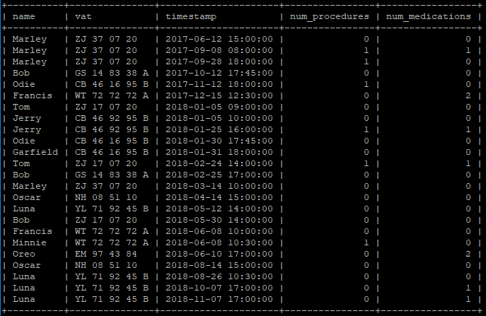
drop view if exists dim_animal, dim_date, facts_consults, prc_tbl, prs_tbl;

drop table if exists produced_indicator;
drop table if exists test_procedure;
drop table if exists radiography;
drop table if exists indicator;
drop table if exists performed;
drop table if exists procedure_;
drop table if exists prescription;
drop table if exists medication;
drop table if exists consult_diagnosis;
drop table if exists diagnosis_code;
drop table if exists participation;
drop table if exists consult;
drop table if exists animal;
drop table if exists generalization_species;
drop table if exists species;
drop table if exists assistant;
drop table if exists veterinary;
drop table if exists phone_number;
drop table if exists client;
drop table if exists person;
create table person (
VAT varchar(255),
name varchar(255),
address_street varchar(255),
address_city varchar(255),
address_zip varchar(255),
primary key (VAT)
);
create table phone_number (
VAT varchar(255),
phone varchar(255),
primary key(phone),
foreign key(VAT) references person(VAT) on delete cascade on update cascade
);
create table client (
VAT varchar(255),
foreign key(VAT) references person(VAT) on delete cascade on update cascade
);
create table veterinary (
VAT varchar(255),
specialization varchar(255),
bio varchar(255),
foreign key(VAT) references person(VAT) on delete cascade on update cascade
);
create table assistant (
VAT varchar(255),
foreign key(VAT) references person(VAT) on delete cascade on update cascade
);
create table species (
name varchar(255),
descc varchar(255),
primary key (name)
);
create table generalization_species (
name1 varchar(255),
name2 varchar(255),
primary key(name1),
foreign key (name1) references species(name) on delete cascade on update cascade,
foreign key (name2) references species(name) on delete cascade on update cascade
);
create table animal (
name varchar(255),
VAT varchar(255),
species_name varchar(255),
colour varchar(255),
gender varchar(255),
birth_year year,
age int,
primary key(name, VAT),
foreign key (VAT) references client(VAT) on delete cascade on update cascade,
foreign key(species_name) references species(name) on delete cascade on update cascade
);
create table consult (
name varchar(255),
VAT_owner varchar(255),
date_timestamp timestamp,
s varchar(255),
o varchar(255),
aa varchar(255),
p varchar(255),
VAT_client varchar(255),
VAT_vet varchar(255),
weight numeric(5,2),
primary key(name, VAT_owner, date_timestamp),
foreign key(name, VAT_owner) references animal(name,VAT) on delete cascade on update cascade,
foreign key(VAT_client) references client(VAT) on delete cascade on update cascade,
foreign key(VAT_vet) references veterinary(VAT) on delete cascade on update cascade,
check(weight>0)
);
create table participation (
name varchar(255),
VAT_owner varchar(255),
date_timestamp timestamp,
VAT_assistant varchar(255),
primary key(name, VAT_owner, date_timestamp, VAT_assistant),
foreign key(name, VAT_owner, date_timestamp) references consult(name,VAT_owner,date_timestamp) on delete cascade on update cascade,
foreign key(VAT_assistant) references assistant(VAT) on delete cascade on update cascade
);
create table diagnosis_code (
code varchar(255),
name varchar(255),
primary key(code)
);
create table consult_diagnosis (
code varchar(255),
name varchar(255),
VAT_owner varchar(255),
date_timestamp timestamp,
primary key(code, name, VAT_owner, date_timestamp),
foreign key(name, VAT_owner, date_timestamp) references consult(name,VAT_owner,date_timestamp) on delete cascade on update cascade,
foreign key(code) references diagnosis_code(code) on delete cascade on update cascade
);
create table medication (
name varchar(255),
lab varchar(255),
dosage varchar(255),
primary key(name, lab, dosage)
);
create table prescription (
code varchar(255),
name varchar(255),
VAT_owner varchar(255),
date_timestamp timestamp,
name_med varchar(255),
lab varchar(255),
dosage varchar(255),
regime varchar(255),
primary key(code, name, VAT_owner, date_timestamp, name_med,lab,dosage),
foreign key(name, VAT_owner, date_timestamp) references consult(name,VAT_owner,date_timestamp) on delete cascade on update cascade,
foreign key(name_med, lab, dosage) references medication(name,lab,dosage) on delete cascade on update cascade,
foreign key(code) references diagnosis_code(code) on delete cascade on update cascade
);
create table indicator (
name varchar(255),
reference_value numeric(10,2),
units varchar(255),
description varchar(255),
primary key(name)
);
create table procedure_ (
name varchar(255),
VAT_owner varchar(255),
date_timestamp timestamp,
num int,
description varchar(255),
primary key(name, VAT_owner, date_timestamp, num),
foreign key(name, VAT_owner, date_timestamp) references consult(name,VAT_owner,date_timestamp) on delete cascade on update cascade
);
create table performed (
name varchar(255),
VAT_owner varchar(255),
date_timestamp timestamp,
num int,
VAT_assistant varchar(255),
primary key(name, VAT_owner, date_timestamp,num,VAT_assistant),
foreign key(name, VAT_owner, date_timestamp,num) references procedure_(name,VAT_owner,date_timestamp,num) on update cascade,
foreign key(VAT_assistant) references assistant(VAT) on delete cascade on update cascade
);
create table radiography (
name varchar(255),
VAT_owner varchar(255),
date_timestamp timestamp,
num int,
file varchar(255),
primary key(name, VAT_owner, date_timestamp, num),
foreign key(name, VAT_owner, date_timestamp, num) references procedure_(name, VAT_owner, date_timestamp, num) on delete cascade on update cascade
);
create table test_procedure (
name varchar(255),
VAT_owner varchar(255),
date_timestamp timestamp,
num int,
type varchar(255),
primary key(name, VAT_owner, date_timestamp, num),
foreign key(name, VAT_owner, date_timestamp, num) references procedure_(name, VAT_owner, date_timestamp, num) on delete cascade on update cascade,
check(type = 'blood' or type='urine')
);
create table produced_indicator (
name varchar(255),
VAT_owner varchar(255),
date_timestamp timestamp,
num int,
indicator_name varchar(255),
value float,
primary key(name, VAT_owner, date_timestamp, num, indicator_name),
foreign key(name, VAT_owner, date_timestamp, num) references procedure_(name, VAT_owner, date_timestamp, num) on delete cascade on update cascade,
foreign key(indicator_name) references indicator(name) on delete cascade on update cascade
);
Database population
Below we present the code used to populate the database:
insert into species values ('mammal', 'Mammals are a clade of endothermic amniotes that possesses a neocortex, hair, three middle ear bones, and mammary glands. ');
insert into species values ('aviary', 'An aviary is a large enclosure for confining birds.');
insert into species values ('cat', 'A cat is a small, typically furry, carnivorous mammal');
insert into generalization_species values ('cat','mammal');
insert into species values ('dog','Dogs (Canis lupus familiaris) are domesticated mammals, not natural wild animals. They were originally bred from wolves');
insert into generalization_species values ('dog','mammal');
insert into species values ('bird', 'Birds are a group of vertebrates which evolved from dinosaurs. They are endothermic, with feathers');
insert into generalization_species values ('bird','aviary');
insert into species values ('mouse','A mouse is a rodent, which is a kind of mammal. It has a pointed snout, small rounded ears, a body-length scaly tail and a high breeding rate');
insert into generalization_species values ('mouse','mammal');
insert into species values ('labrador','Labrador is a type of retriever-gun dog. The Labrador is one of the most popular breeds of dog in Canada, the United Kingdom and the United States.');
insert into generalization_species values ('labrador','dog');
insert into species values ('parrot bird','Parrots, also known as psittacines are birds of the roughly 393 species in 92 genera that make up the order Psittaciformes, found in most tropical and subtropical regions');
insert into generalization_species values ('parrot bird','bird');
insert into species values ('canary','The domestic canary, often simply known as the canary is a domesticated form of the wild canary, a small songbird in the finch family originating from the Macaronesian Islands');
insert into generalization_species values ('canary','bird');
insert into species values ('pug','The Pug is a breed of dog with physically distinctive features of a wrinkly, short-muzzled face, and curled tail.');
insert into generalization_species values ('pug','dog');
insert into species values ('siamese','The Siamese cat is one of the first distinctly recognized breeds of Asian cat.');
insert into generalization_species values ('siamese','cat');
insert into species values ('scottish fold','The Scottish Fold is a breed of domestic cat with a natural dominant-gene mutation that affects cartilage throughout the body, causing the ears to fold.');
insert into generalization_species values ('scottish fold','cat');
-- Persons and their respective pets
--client
insert into person values ('EA 24 06 86','John Smith','Crown Street','London','SW3 1AQ');
insert into phone_number values('EA 24 06 86','070 2699 7334');
insert into veterinary values('EA 24 06 86', 'General Practicioneer', 'Pop culture geek. Vet. Unapologetic social media lover. Travel fanatic.');
insert into client values('EA 24 06 86');
insert into animal values('Shiro','EA 24 06 86','labrador','Brown','M','2017','1');
--veterinary
insert into person values('CY 10 60 11 A',' Liz Wilson','Guild Street','London','EC1P 1RE');
insert into phone_number values('CY 10 60 11 A','079 4132 9210');
insert into veterinary values('CY 10 60 11 A', 'Surgery', 'Coffee buff. Web enthusiast. Surgery Vet. Gamer. Avid organizer.');
--assistant
insert into person values('SM 62 10 29 D','Joshua Pearson','Parker Road','Croydon','CR7 QS8');
insert into phone_number values('SM 62 10 29 D','070 7514 9424');
insert into assistant values('SM 62 10 29 D');
--client
insert into person values('CB 46 16 95 B','Jon Arbuckle','Sumner Road','Croydon','CR7 H3P');
insert into phone_number values('CB 46 16 95 B','070 2149 6062');
insert into assistant values('CB 46 16 95 B');
insert into client values('CB 46 16 95 B');
insert into animal values('Garfield','CB 46 16 95 B','cat','Orange','M','2014','4');
insert into animal values('Odie','CB 46 16 95 B','pug','White','M','2015','3');
--client without animal
insert into person values('ZA 16 10 97','Walter White', 'Albuquerque','Albuquerque City', 'AB7 WWN');
insert into phone_number values('ZA 16 10 97','078 6911 1109');
insert into client values('ZA 16 10 97');
--client
insert into person values('NH 08 51 10','Liam Morgan', 'Ecclesbourne Road','Croydon', 'CR7 7BN');
insert into phone_number values('NH 08 51 10','078 6008 1591');
insert into client values('NH 08 51 10');
insert into animal values('Oscar','NH 08 51 10','labrador','Grey','M','2014','4');
--client
insert into person values('EM 97 43 84','Freya Bird','London Road','London','SW16 4DP');
insert into phone_number values('EM 97 43 84','077 7080 5592');
insert into client values('EM 97 43 84');
insert into animal values('Oreo','EM 97 43 84','siamese','White','M','2017','1');
--client
insert into person values('GS 14 83 38 A','Ethan Peacock','Streatham Vale','London', 'SW16 5TB');
insert into phone_number values('GS 14 83 38 A','079 7140 4420');
insert into client values('GS 14 83 38 A');
insert into animal values('Bob','GS 14 83 38 A','parrot bird','Green','M','2017','1');
insert into animal values('Boby','GS 14 83 38 A','bird','Blue','M','2017','1');
--client
insert into person values('YL 71 92 45 B','Henry Dennis', 'Grove Road','Mitcham','CR4 1AB');
insert into phone_number values('YL 71 92 45 B','079 1080 0169');
insert into client values('YL 71 92 45 B');
insert into animal values('Luna','YL 71 92 45 B','labrador','Black','F','2010','8');
--client
insert into person values('ZJ 37 07 20','Ethan Bennett','Jebb Avenue','London','SW2 5XF');
insert into phone_number values('ZJ 37 07 20','079 7422 0554');
insert into client values('ZJ 37 07 20');
insert into animal values('Marley','ZJ 37 07 20','pug','Brown','M','2012','6');
--client
insert into person values('WT 72 72 72 A','Megan Leonard','Streatham Road','London','SW16 1BS');
insert into phone_number values('WT 72 72 72 A','077 7408 9030');
insert into client values('WT 72 72 72 A');
insert into animal values('Francis','WT 72 72 72 A','siamese','Black','M','2016','2');
insert into animal values('Minnie','WT 72 72 72 A','scottish fold','Black','F','2016','2');
--client
insert into person values('CB 46 92 95 B', 'John Doe','Crown Lane', 'London', 'SW16 3JG');
insert into phone_number values('CB 46 92 95 B', '070 2179 6060');
insert into client values('CB 46 92 95 B');
insert into animal values('Jerry','CB 46 92 95 B','mouse','Brown','M','2015','3');
--client
insert into person values('ZJ 17 07 20', 'Ethan Williams','Sutton Ct Road', 'Sutton', 'SM1 4RQ');
insert into phone_number values('ZJ 17 07 20', '079 7422 0004');
insert into client values('ZJ 17 07 20');
insert into animal values('Tom','ZJ 17 07 20','scottish fold','Grey','M','2015','3');
insert into animal values('Bob','ZJ 17 07 20','canary','Grey','M','2018','0');
insert into animal values('Bobbie','ZJ 17 07 20','bird','Grey','M','2018','0');
--Consults and respective tests, diagnostics, medications
insert into consult values('Tom','ZJ 17 07 20','2018-01-05 09:00:00','Tail appears broken after an iron fell on top of it','several fractures appeard on radiography','several fractures from trauma','cast on the tail','ZJ 17 07 20','EA 24 06 86',1.5);
insert into consult values('Tom','ZJ 17 07 20','2018-02-24 14:00:00','Tom altough disturbed from the presence of the cast, managed to continue normal life','full healing as shown radiography','clear','remove cast','ZJ 17 07 20','EA 24 06 86',1.7);
insert into diagnosis_code values('BRKTAIL','Broken tail');
insert into procedure_ values ('Tom','ZJ 17 07 20','2018-02-24 14:00:00',1,'Tail X-Ray');
insert into radiography values ('Tom','ZJ 17 07 20','2018-02-24 14:00:00',1,'C:x-ray');
insert into consult_diagnosis values('BRKTAIL','Tom','ZJ 17 07 20','2018-01-05 09:00:00');
insert into performed values('Tom','ZJ 17 07 20','2018-02-24 14:00:00',1,'SM 62 10 29 D');
insert into medication values('Paracetemol','Dayer','100mg');
insert into prescription values('BRKTAIL','Tom','ZJ 17 07 20','2018-02-24 14:00:00','Paracetemol','Dayer','100mg','12/12h');
insert into consult values('Bob','ZJ 17 07 20','2018-05-30 14:00:00','Nothing of concern','','','','ZJ 17 07 20','EA 24 06 86',0.5);
insert into consult values('Jerry','CB 46 92 95 B','2018-01-05 10:00:00','Jerry doesnt want to eat and remains still all the time','urinanalysis shows presence of toxin','poisioning','admission to clinic and surveillance','CB 46 92 95 B','EA 24 06 86',0.15);
insert into consult values('Jerry','CB 46 92 95 B','2018-01-25 16:00:00','Jerry eats and plays','urinanalysis shows no presence of toxin','clear','discharge','CB 46 92 95 B','EA 24 06 86',0.2);
insert into diagnosis_code values('POSN','Poisoning');
insert into procedure_ values ('Jerry','CB 46 92 95 B','2018-01-25 16:00:00',1,'Poison');
insert into test_procedure values ('Jerry','CB 46 92 95 B','2018-01-25 16:00:00',1,'urine');
insert into indicator values ('Poison','0','picograms','Amount of poison');
insert into indicator values ('Kidney Enzime 2','150','milligrams','Level of enzimes of kidney function 2');
insert into indicator values ('Creatinine level','0.5','milligrams','Level of creatinine');
insert into indicator values ('Carnine Enzime','250','picograms','Level of enzimes of Carnine');
insert into produced_indicator values ('Jerry','CB 46 92 95 B','2018-01-25 16:00:00',1,'Poison','9');
insert into medication values('Tarinum Forte','Dayer','10mg');
insert into prescription values('POSN','Jerry','CB 46 92 95 B','2018-01-25 16:00:00','Tarinum Forte','Dayer','10mg','12/12h for 5 days IV');
insert into consult_diagnosis values('POSN','Jerry','CB 46 92 95 B','2018-01-05 10:00:00');
insert into consult values('Marley','ZJ 37 07 20','2018-03-14 10:00:00','Looks fat and is unable to jump','Obesity','high weight ','Medication, meal cut and excercise','ZJ 37 07 20','EA 24 06 86',40.2);
insert into diagnosis_code values('DIBT','Diabetes');
insert into consult_diagnosis values('DIBT','Marley','ZJ 37 07 20','2018-03-14 10:00:00');
insert into consult values('Marley','ZJ 37 07 20','2017-09-08 08:00:00','Doesnt want to eat or play','High level of enzimes','Kidney failure','Medication and admission','ZJ 37 07 20','CY 10 60 11 A',30.8);
insert into diagnosis_code values('KDNFLR','Kidney failure');
insert into medication values('Adaytidah polipstiso','Dayer','50mg');
insert into prescription values('KDNFLR','Marley','ZJ 37 07 20','2017-09-08 08:00:00','Adaytidah polipstiso','Dayer','50mg','everyday for 2 weeks');
insert into procedure_ values ('Marley','ZJ 37 07 20','2017-09-08 08:00:00',1,'Enzime test');
insert into test_procedure values ('Marley','ZJ 37 07 20','2017-09-08 08:00:00',1,'blood');
insert into indicator values ('Kidney Enzime','115','milligrams','Level of enzimes of kidney function');
insert into produced_indicator values ('Marley','ZJ 37 07 20','2017-09-08 08:00:00',1,'Kidney Enzime','2');
insert into produced_indicator values ('Marley','ZJ 37 07 20','2017-09-08 08:00:00',1,'Creatinine level','2');
insert into consult_diagnosis values('KDNFLR','Marley','ZJ 37 07 20','2017-09-08 08:00:00');
insert into participation values ('Marley','ZJ 37 07 20','2018-03-14 10:00:00','CB 46 16 95 B');
insert into consult values('Marley','ZJ 37 07 20','2017-06-12 15:00:00','Nothing in particular','No indication of problems','Healthy','Annual vaccination','ZJ 37 07 20','EA 24 06 86',28);
insert into consult values('Marley','ZJ 37 07 20','2017-09-28 18:00:00','Limps on the left paw','X-ray shows broken limb','Broken paw','Cast','ZJ 37 07 20','CY 10 60 11 A',27);
insert into diagnosis_code values('BRKPAW','Broken paw');
insert into procedure_ values ('Marley','ZJ 37 07 20','2017-09-28 18:00:00',1,'paw X-Ray');
insert into radiography values ('Marley','ZJ 37 07 20','2017-09-28 18:00:00',1,'C:x-ray');
insert into consult_diagnosis values('BRKPAW','Marley','ZJ 37 07 20','2017-06-12 15:00:00');
insert into consult values('Francis','WT 72 72 72 A','2018-06-08 10:00:00','Nothing in particular','No indication of problems','Healthy','Annual vaccination','WT 72 72 72 A','EA 24 06 86',2.0);
insert into consult values('Francis','WT 72 72 72 A','2017-12-15 12:30:00','Sneezes a lot, doesnt eat or play','High temperature and reddish throat','Feline Flue','Medication','WT 72 72 72 A','CY 10 60 11 A',0.7);
insert into diagnosis_code values('FLFLU','Feline Flu');
insert into medication values('Ibuprofen','Mistic','35mg');
insert into prescription values('FLFLU','Francis','WT 72 72 72 A','2017-12-15 12:30:00','Paracetemol','Dayer','100mg','12/12h until next consult');
insert into prescription values('FLFLU','Francis','WT 72 72 72 A','2017-12-15 12:30:00','Ibuprofen','Mistic','35mg','12/12h until next consult');
insert into consult_diagnosis values('FLFLU','Francis','WT 72 72 72 A','2018-06-08 10:00:00');
insert into consult values('Minnie','WT 72 72 72 A','2018-06-08 10:30:00','Large belly','Eco shows 3 fetus','Pregnant','No action required','WT 72 72 72 A','EA 24 06 86',2.6);
insert into procedure_ values ('Minnie','WT 72 72 72 A','2018-06-08 10:30:00',1,'Abdominal Eco');
insert into radiography values ('Minnie','WT 72 72 72 A','2018-06-08 10:30:00',1,'C:Ecos');
insert into consult values('Luna','YL 71 92 45 B','2018-05-12 14:00:00','Nothing in particular','No indication of problems','Healthy','Annual vaccination','YL 71 92 45 B','EA 24 06 86',14);
insert into consult values('Luna','YL 71 92 45 B','2018-08-26 10:30:00','Nothing in particular','No indication of problems','Healthy','Annual vaccination','YL 71 92 45 B','EA 24 06 86',13);
insert into consult values('Bob','GS 14 83 38 A','2017-10-12 17:45:00','Nothing in particular','No indication of problems','Healthy','No action required','GS 14 83 38 A','EA 24 06 86',0.8);
insert into consult values('Bob','GS 14 83 38 A','2018-02-25 17:00:00','Found outdoors, appears lost','No indication of problems','Healthy','No action required','ZJ 17 07 20','EA 24 06 86',0.7);
insert into consult values('Oreo','EM 97 43 84','2018-06-10 17:00:00','Sneezes a lot, doesnt eat or play','High temperature and reddish throat','Feline Flue','Medication','EM 97 43 84','CY 10 60 11 A',4);
insert into prescription values('FLFLU','Oreo','EM 97 43 84','2018-06-10 17:00:00','Paracetemol','Dayer','100mg','12/12h until next consult');
insert into prescription values('FLFLU','Oreo','EM 97 43 84','2018-06-10 17:00:00','Ibuprofen','Mistic','35mg','12/12h until next consult');
insert into consult_diagnosis values('FLFLU','Oreo','EM 97 43 84','2018-06-10 17:00:00');
insert into consult values('Oscar','NH 08 51 10','2018-04-14 15:00:00','Looks fat and is unable to jump','Obese','high weight and fat','Medication, meal cut and excercise','NH 08 51 10','EA 24 06 86',40.2);
insert into consult values('Oscar','NH 08 51 10','2018-08-14 15:00:00','Nothing in particular','No indication of problems','Healthy','No action required','NH 08 51 10','EA 24 06 86',28.2);
insert into consult values('Odie','CB 46 16 95 B','2018-01-30 17:45:00','Nothing in particular','No indication of problems','Healthy','No action required','CB 46 16 95 B','EA 24 06 86',10);
insert into consult values('Odie','CB 46 16 95 B','2017-11-12 18:00:00','Limps on the left paw','X-ray shows broken limb','Broken paw','Cast','CB 46 16 95 B','CY 10 60 11 A',12);
insert into procedure_ values ('Odie','CB 46 16 95 B','2017-11-12 18:00:00',1,'paw X-Ray');
insert into radiography values ('Odie','CB 46 16 95 B','2017-11-12 18:00:00',1,'C:x-ray');
insert into consult_diagnosis values('BRKPAW','Odie','CB 46 16 95 B','2017-11-12 18:00:00');
insert into consult values('Garfield','CB 46 16 95 B','2018-01-31 18:00:00','Looks fat and is unable to jump','Obese','High weight and fat percentage','Medication, meal cut and excercise','NH 08 51 10','EA 24 06 86',6.2);
insert into consult_diagnosis values ('DIBT','Garfield','CB 46 16 95 B','2018-01-31 18:00:00');
insert into consult values ('Shiro', 'EA 24 06 86', '2018-01-30 17:45:00', 'Nothing in particular', 'No indication of problems', 'Healthy', 'No action required', 'EA 24 06 86', 'CY 10 60 11 A', 8);
insert into consult values('Luna','YL 71 92 45 B','2018-10-07 17:00:00','Tail injury due a fight','Lose a big quantity of blood','Broken tail','Medication','ZJ 17 07 20','EA 24 06 86',0.7);
insert into prescription values('BRKTAIL','Luna','YL 71 92 45 B','2018-10-07 17:00:00','Paracetemol','Dayer','100mg','12/12h until next consult');
insert into consult_diagnosis values('BRKTAIL','Luna','YL 71 92 45 B','2018-10-07 17:00:00');
insert into consult values('Luna','YL 71 92 45 B','2018-11-07 17:00:00','Check tail injury due a fight','Still lose a big quantity of blood','Broken tail','Medication','ZJ 17 07 20','EA 24 06 86',0.7);
insert into prescription values('BRKTAIL','Luna','YL 71 92 45 B','2018-11-07 17:00:00','Paracetemol','Dayer','100mg','12/12h until next consult');
insert into consult_diagnosis values('BRKTAIL','Luna','YL 71 92 45 B','2018-11-07 17:00:00');

